HIT3061 – Software Team Project - Semester 2, 2013

Leap Motion Development

Software Requirements Specification

**Daniel Corsaletti**

SID: 6450458

E: 6450458@student.swin.edu.au

M: 0433 536 150

**Joshua Stopper**

SID: 5571391

E: 5571391@student.swin.edu.au

M: 0430 714 887

**Shengwei Li**

SID: 749999x

E: 749999x@student.swin.edu.au

M: 0420 478 750

**Minh Duc Nguyen**

SID: 171001x

E: 171001x@student.swin.edu.au

M: 0412 179 265

**Tran Xuong Tran**

SID: 6700691

E: 6700691@student.swin.edu.au

M: 0433 345 105

**Table 1. Document Change Control**

|  |  |  |  |
| --- | --- | --- | --- |
| Version | Date | Author | Changes |
| 0.1 | 27/08/2013 | Joshua Stopper | Create Document  Create Content Areas  Names added |
| 0.9 | 02/09/2013 | Joshua Stopper | Continue to fill out remain sections |
| 0.91 | 02/09/2013 | Minh Duc Nguyen | Continue Section 4 |
| 0.92 | 02/09/2013 | Tran Xuong Tran | Continue Section 2 |
| 0.93 | 04/09/2013 | Tran Xuong Tran | Reformat some content |

**Table 2. Document Sign Off**

|  |  |  |
| --- | --- | --- |
| Name | Signature | Date |
| Joshua Stopper |  |  |
| Minh Duc Nguyen |  |  |
| Tran Xuong Tran |  |  |
| Daniel Corsaletti |  |  |
| Shengwei Li |  |  |

Table of Contents

1 – Introduction 3

1.1 – Purpose 3

1.2 – Scope 3

1.3 – Definitions, Acronyms and Abbreviations 4

2 - Overall Description 4

2.1 - Product Features 4

2.2 System Requirements 5

2.2.1 - Development Requirements 5

2.2.2 – Production Requirements 5

2.3 Documentation 5

3 System 6

4 Interface Requirements 6

4.1 User Interfaces 6

4.2 Hardware Interfaces 7

4.3 Software Interfaces 7

4.4 Communication Interfaces 8

5 References: 8

# 1 – Introduction

Over one year ago, Dr. Phillip Michael from the Royal Victorian Eye & Ear hospital discovered the capability of the Leap Motion Controller to track 1/100th of a millimeter changes in the location of fingers at up to 200 times a second. In an attempt to advance the state of the industry, Dr. Phillip Michael has brought the project to Swinburne University to make the advancement a reality.

In collaboration with Swinburne University, Dr. Phillip Michael and select students, the Leap Motion Controller will attempted to be used to detect tremors in surgeons hands whilst outputting to a display a variety of details about select points of the hand and fingers.

In continued analysis by Dr. Phillip Michael of the Leap Motion Controller and what can be achieved, the use cases attributed with controller expanded from not only surgeons hand but also to patients with Parkinson’s disease. The controller and developed software in this case will provide Drs. as well as patients the ability to see the level of progression of the disease, as well as whether or not medications to treat the disease are working.

## – Purpose

The purpose of this document is to detail the requirements of the project so that a product can be developed that meets the requirements. As such, this document is for the client and the developers so that an agreement can be reached.

## – Scope

**Name**

* Tremor analysis with Leap Motion

**What the software will do**

* Display the level of tremor in the hand in Hertz (metric) to a display
* Software contains brief tutorials in use of the software
* Software contains instruction in the use of the software in real time.
* Software provides a means to export the data recorded by the leap motion device to a file
* Software provides a means to import the data saved to a file for analysis, replay
* Software provides a means to replay two sets of data for comparison

**What the software will not do**

* Provide analysis of the data recorded outside tremor in hertz
* Be liable in the event that a surgeon has a tremor during operation
* Give a concrete output whether the surgeon is ready for operation

**Application and use of the software**

* Surgeons test their hands pre-operative to determine if they are able to perform
* Drs. Clinics testing tremors in Parkinson’s patients
  + Comparing past results of patients

**Benefits of the software**

* Tremor can be tested in real time without expensive hardware
* Tremor can be detected in a non intrusive way

**Objective of the software**

* To develop software that will interface with the leap motion controller and detect the level of tremor in the hand.

## – Definitions, Acronyms and Abbreviations

*Provide the definition of all terms, acronyms, and abbreviations used in the SRS.*

|  |  |
| --- | --- |
| Word | Definition |
| LM | Leap Motion |
| LMD | Leap Motion Device |
| JS | JavaScript |
| API | Application Programming Interface |
| Local | The software/hardware is being executed/stored on the machine the end user is accessing |
| Remote | The software/hardware is being executed/stored on a machine separate from the end user |
| Hertz | Unit of frequency that defines a rate of change. Hertz defines the rate of change |

# - Overall Description

Leap Motion is a tiny device with a sensor and interact with the computer by an USB cable. People can be tracked the movement of the hands in the natural way such as point, wave, reach and grab.

## 2.1 - Product Features

* Display the level of tremor in the hand in Hertz (metric) to a display
* Software contains brief tutorials in use of the software
* Software contains instruction in the use of the software in real time.
* Software provides a means to export the data recorded by the leap motion device to a file
* Software provides a means to import the data saved to a file for analysis, replay
* Software provides a means to replay two sets of data for comparison

## 2.2 System Requirements

### 2.2.1 - Development Requirements

|  |  |
| --- | --- |
| **Requirement** | **Explanation** |
| Leap Motion Device | This device is what records the motion and sends the data to the computer |
| Leap Motion Driver | This software interfaces with the leap motion device and converts the binary into usable data |
| Leap Motion JSAPI | The Leap Motion JSAPI provides a javascript interface to the leap motion device. |
| Computer | The computer will perform the calculations required by the software |
| Local Web Server | This software will host the code for execution in a web browser |
| Web Browser (Chrome/Firefox/IE/Safari) | The web browser will run the software developed |
| IDE/Text Editor | The software will be developed in this software. |

### 2.2.2 – Production Requirements

|  |  |
| --- | --- |
| **Requirement** | **Explanation** |
| Leap Motion Device | This device is what records the motion and sends the data to the computer |
| Leap Motion Driver | This software interfaces with the leap motion device and converts the binary into usable data |
| Leap Motion JSAPI | The Leap Motion JSAPI provides a javascript interface to the leap motion device. The JSAPI will be included when the web page is loaded, therefore not required locally |
| Computer | The computer will perform the calculations required by the software |
| Web Browser (Chrome/Firefox/IE/Safari) | The web browser will run the software developed |

### 2.2.3 – Hardware Requirements

|  |  |
| --- | --- |
| Component | Minimum Requirements |
| Processor | AMD Phenom ™ II or Intel® Core™ i3, i5, i7 |
| Memory | 2 GB RAM |
|  | USB 2.0 port |

### 2.2.4 – Software Requirements

|  |  |
| --- | --- |
| Software Requirements | |
| Operation System | Windows® 7 or 8 or Mac® OS X 10.7 |
| Browser | Chrome/Firefox/IE/Safari |

## 2.3 Documentation

*List all the documents that will be delivered along with the software. This may include user manuals, tutorials and technical manuals.*

* Real time tutorials in how to use the software
* Manuals in how to install, plug in, and use the hardware
* Manuals in how to install, configure, and use the software
* Testing documentation during the building of the software
  + Use Cases
  + Software outputs

# 3 System

Leap Motion Device

Leap Motion Airspace

Leap Motion JSAPI

Leap Motion JS Controller

HTML – JAVASCRIPT – CSS FILES

# 4 Interface Requirements

## 4.1 User Interfaces

The user will interact with the Leap motion controller via a html webpage developed in HTML5, CSS and JavaScript. The user will choose what type of test they would like to take and then the screen will present them with the required information to take the test.

On the testing page, there is a frame showing the movement of user hand. Also, a sample instruction displays to instruct user in moving the hand to the right spot before conducting the test.

The instruction image can be as the below picture

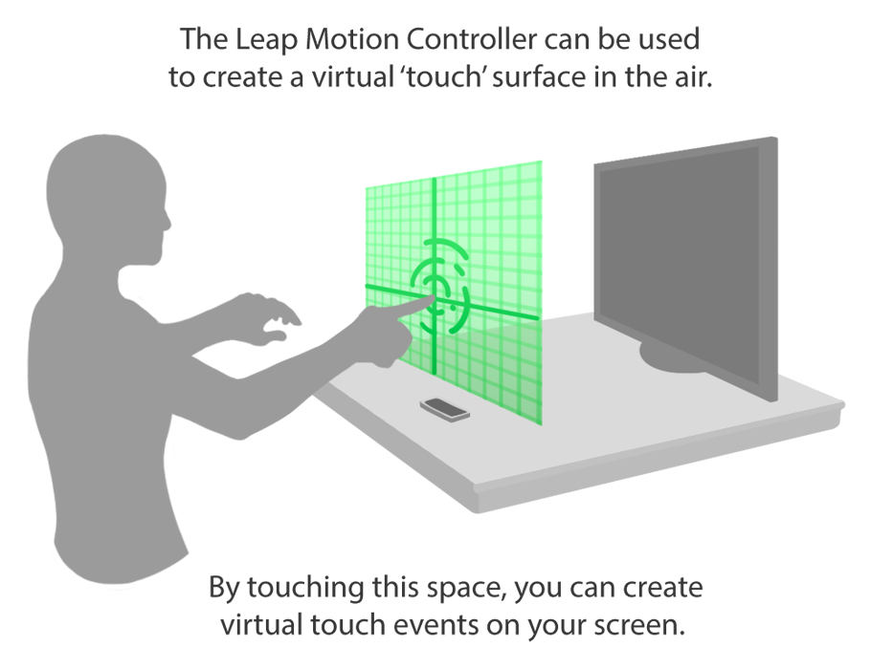

## 4.2 Hardware Interfaces

The leap motion airspace application runs html5 socket server that the leap motion JSAPI communicates with. Therefore requiring a browser that supports html5 sockets such as Chrome, Firefox, and Safari.

In order to run socket server, Node.js library has to be installed. Node.js library can be found on <http://nodejs.com>

Wampserver is the application that includes both of Apache and MySQL that are used to store user information and manage connection session. For the Mac user, Mampstack is the replacement.

## 4.3 Software Interfaces

The frontend we develop will communicate with a remote or local server for file storage; these files will contain recordings of users in a centralized location.

The output of the test will be a set of graphs that collects user moving data. According to the performance and the threshold on the graph, system will generate appropriate report to assess user tremor status.

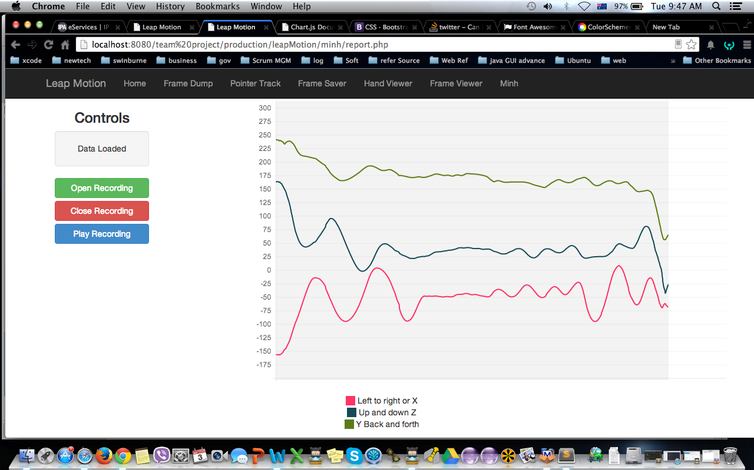

## 4.4 Communication Interfaces

The software will communicate over HTTP to request the pages local or remotely. HTTP Post and get will also be used to place data on the servers

# 5 References:

*1. Hamlyn-Harris, J H , “DEVELOPMENT OF A COMPARATIVE WEAR TEST FOR PVD COATED HELICAL ENDMILLS", Proc. "Materials Conservation, Materials Research Forum 1997, Centre for Advanced Materials Technology (CAMT), Monash University, Melbourne, 1997, pp. 49-52.*

*Don’t forget the page numbers. No-one want’s to read an entire book just to check one little fact.*